# Create New Repository in GitHub server

<https://github.com/maheshwagh2988/MavenProjectTestGit>

Here you can see I have crated my git Repository in GitHub server Name as **“MavenProjectTestGit”**

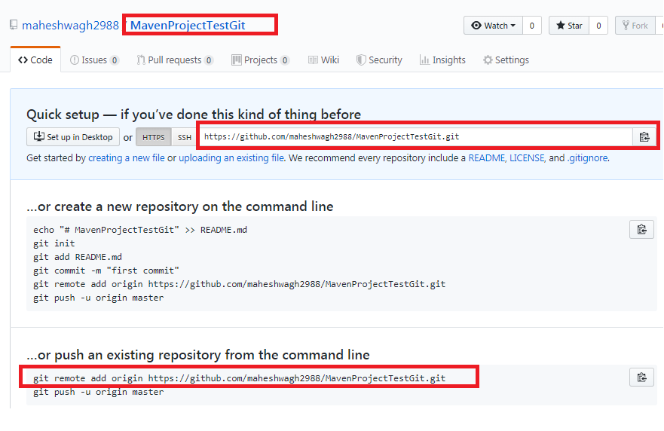

Now In Eclipse IDE create new Maven Project

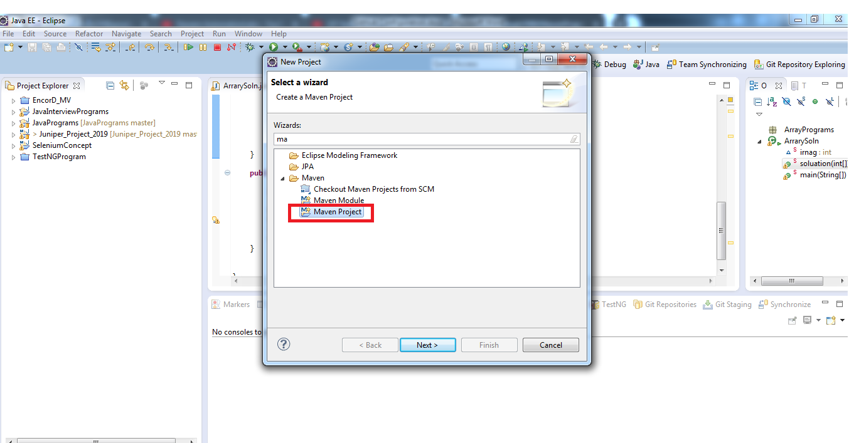

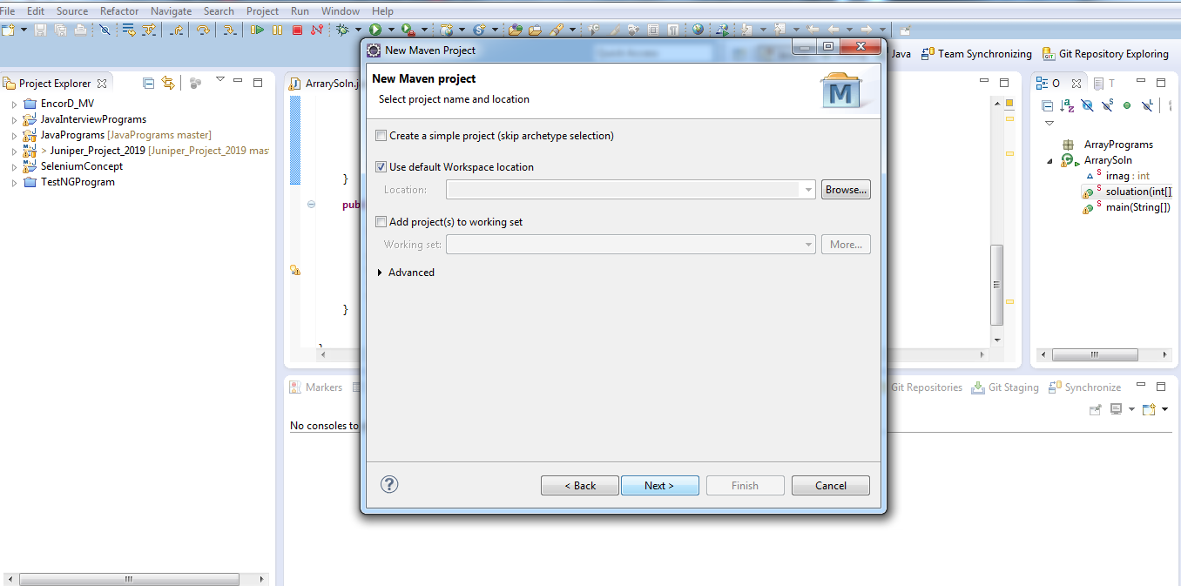

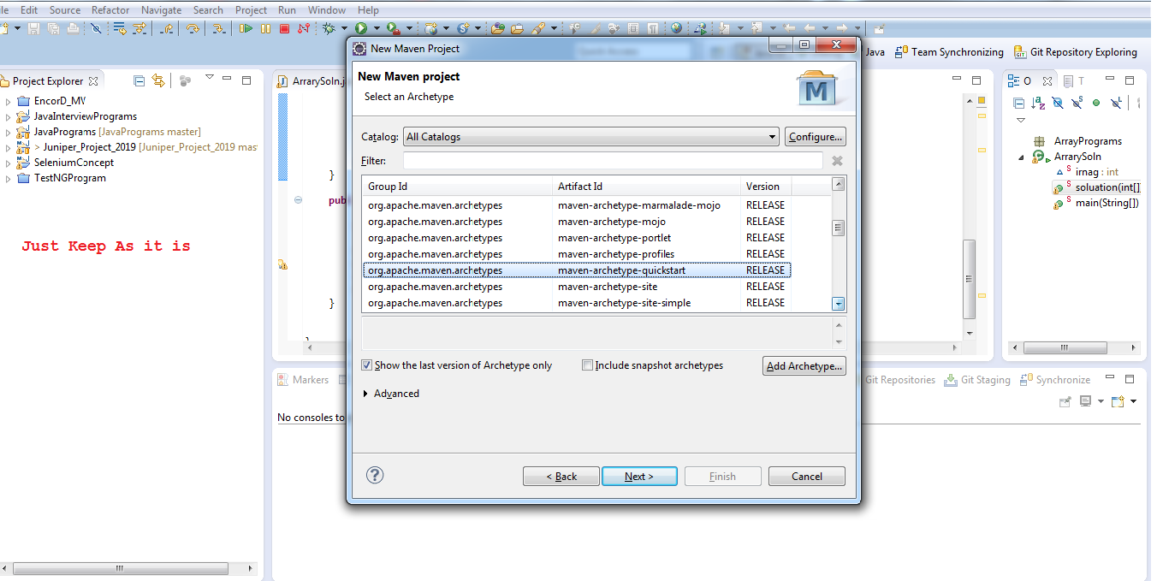

Enter the name of Group and Artifact ID

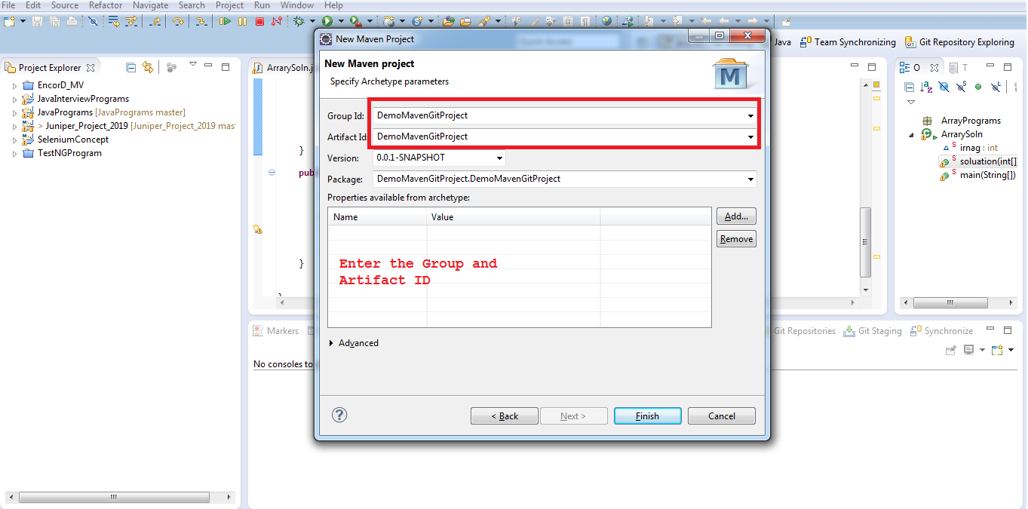

Here the Project Structure has been created   
1) src/main/java you will write your java code

2) src/test/java your test cases will be here

This is defalut package crated you can delete it and create your own packages  
In pom.xml you can add your selenium and TestNg Dependencies

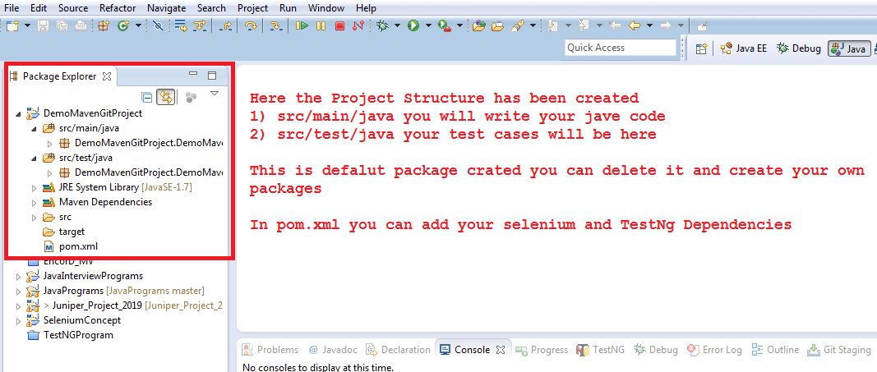

Here I have created some package and wrote test code

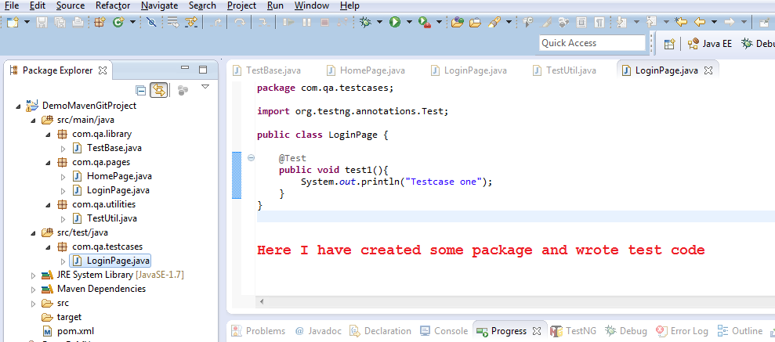

Here you can see your project location on your current system directory

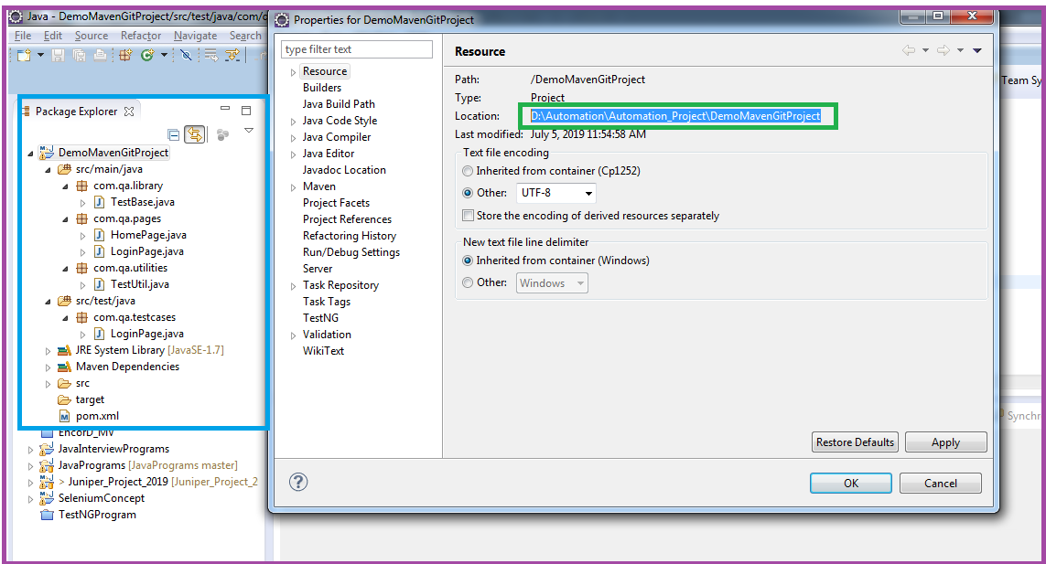

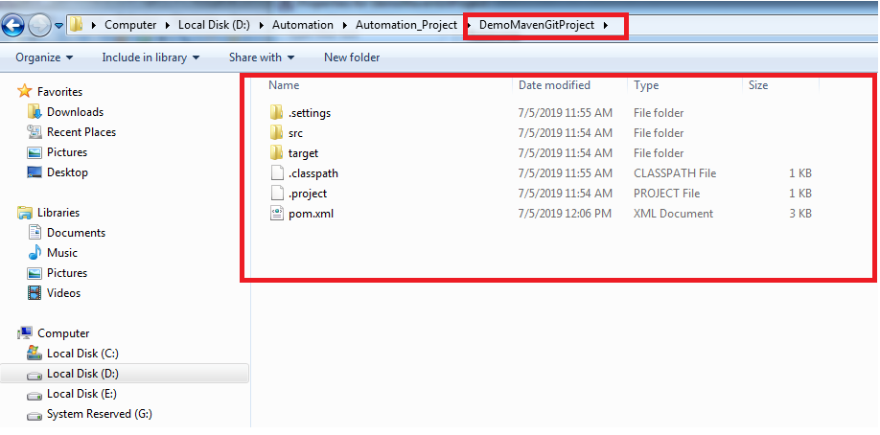

Open command terminal and move to current location

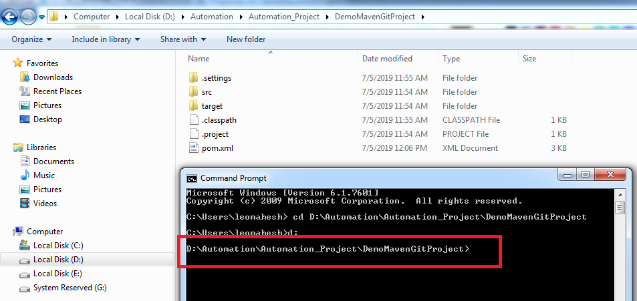

Git init

It will create hidden .git folder in your project directory

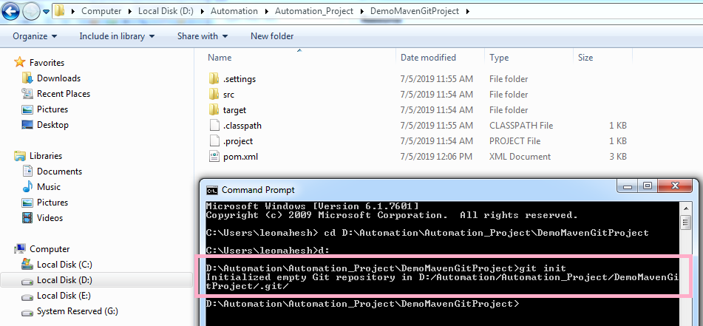

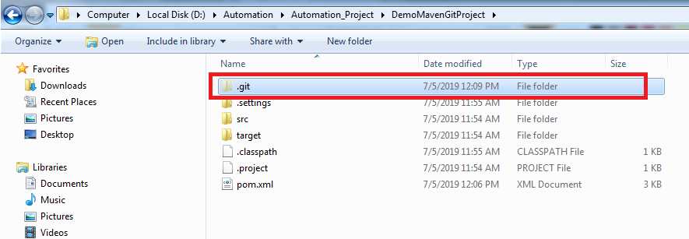

Add below command on cmd and enter it it will create connection with our created repository

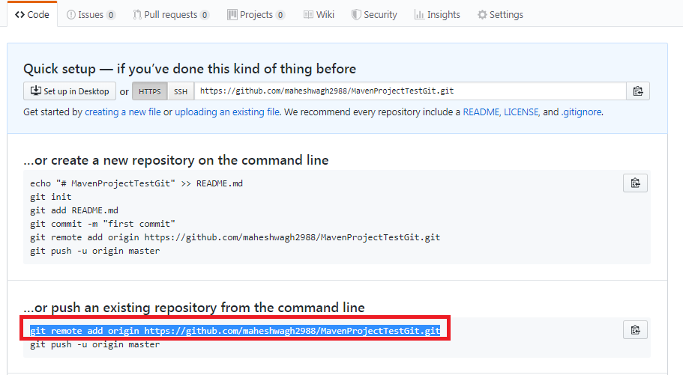

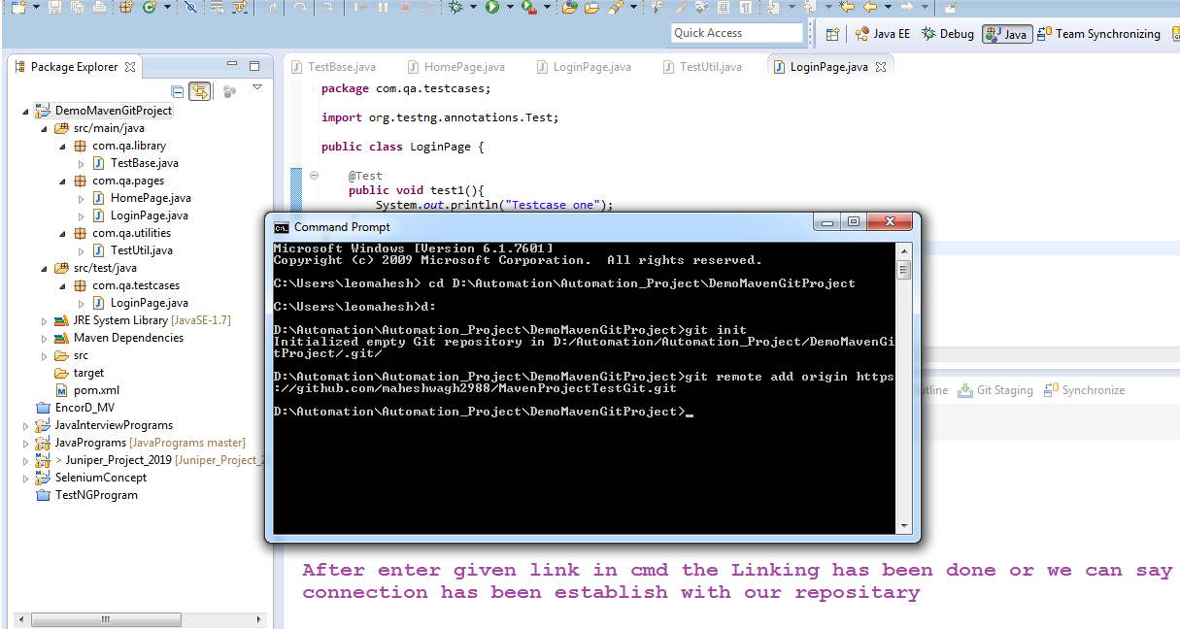

After that check the git status of your current repository

Git status you will read color files that we need to add/ commit for commit we have command

**git add .**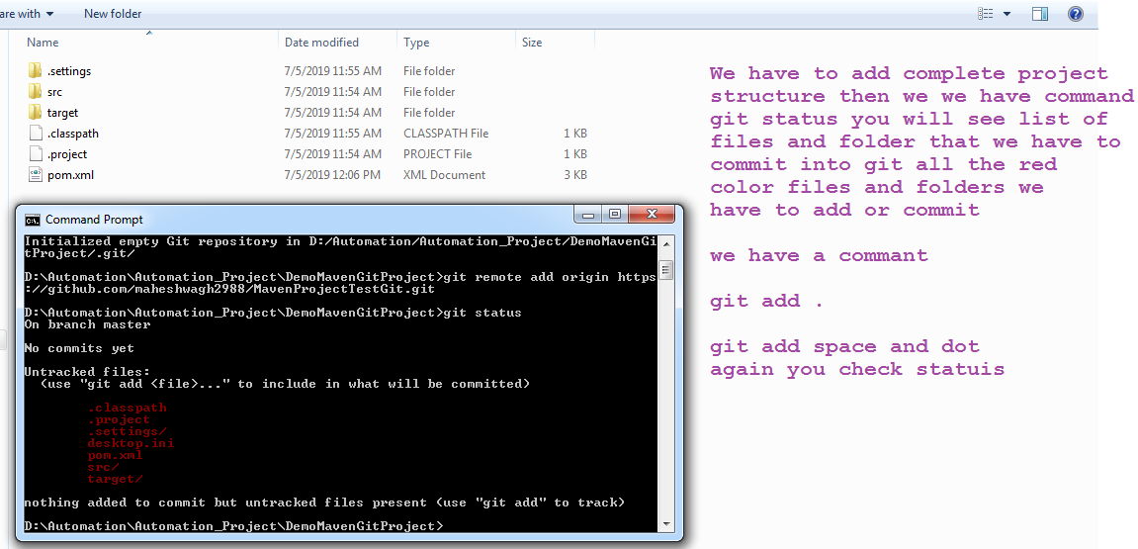

After git add. All the files are added after that you can check status git status

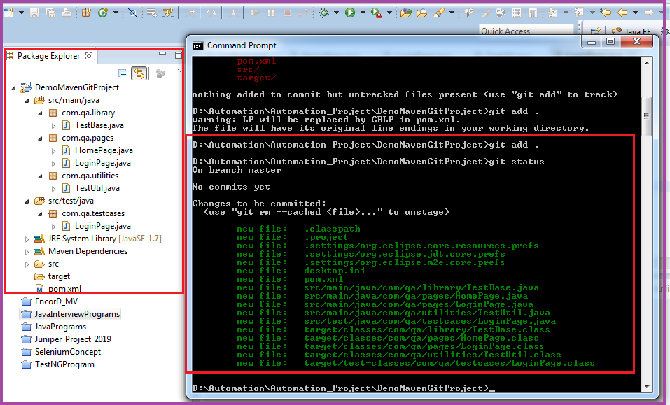

Here now you can commit the code and but not pushed git commit –m ” –m used for Comment”

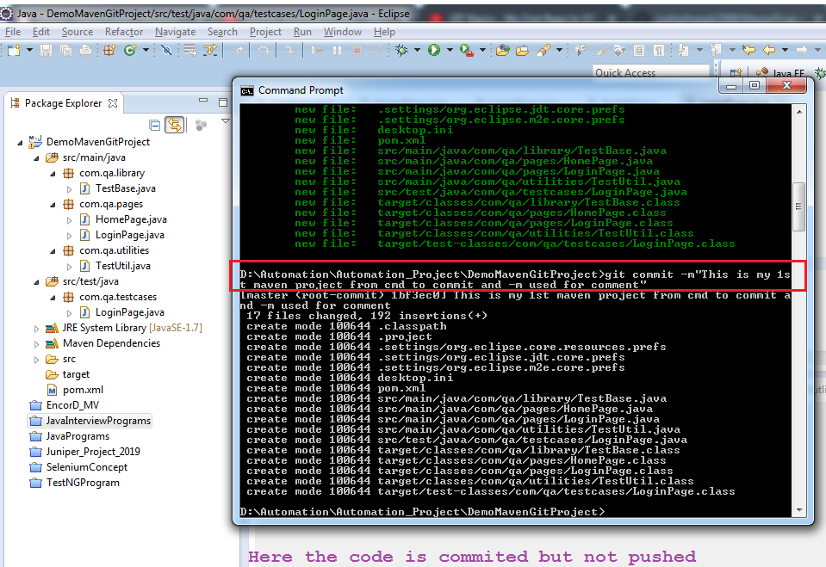

For Push we have to crate ssh key from ssh key generator I have created public ssh key and past into git account

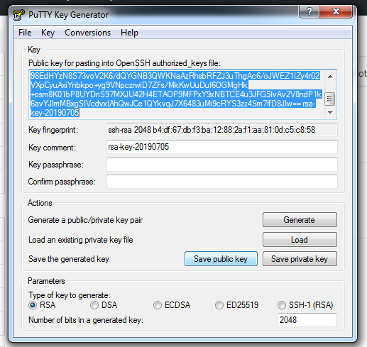

Push the code command ***git push origin master***

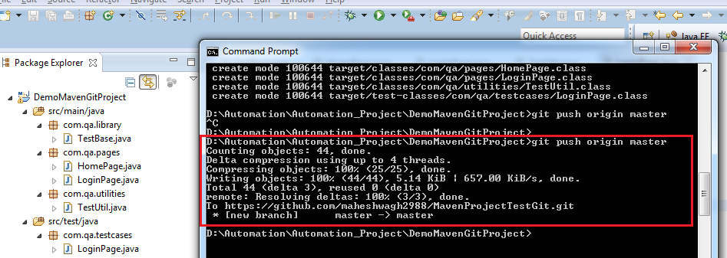

Now you can see code successfully update in git repository in github server

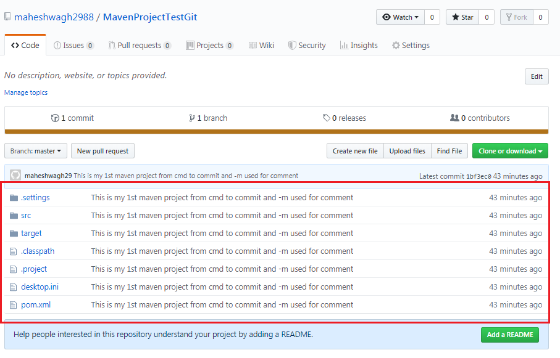

Now create new Search page class and some method also modify some change in Login pages

Now enter the git status

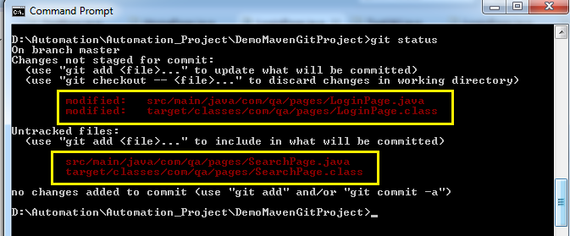

Now add the files the new change again we have to use git add .

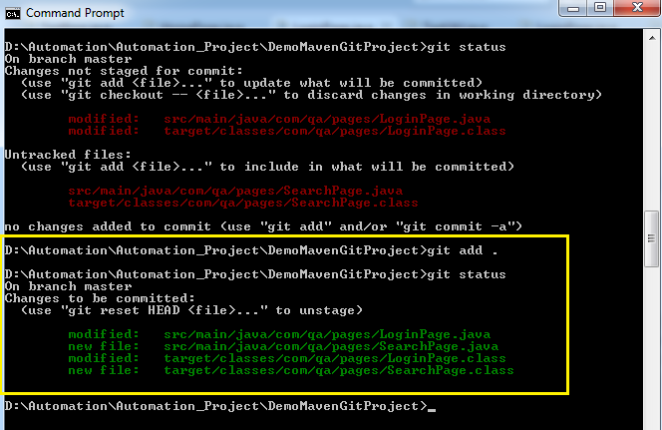

Now commit the changes

Git commit –m “here -m means comment ”

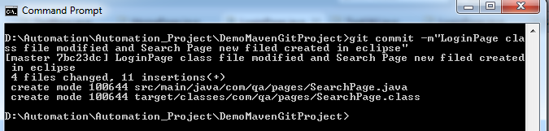

Now Push the changes

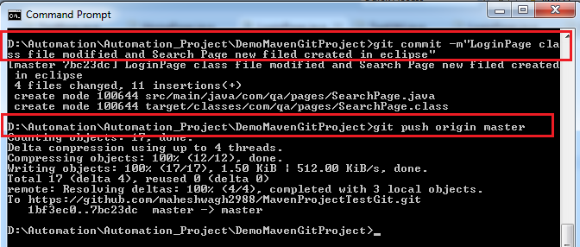

Git clone

Clone means copy from github server to our local system.   
once we close it you can create a project and and import this project into your eclipse

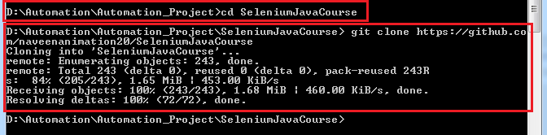

After successfully added project we want to pull something form git you can use below command

Git pull origin master

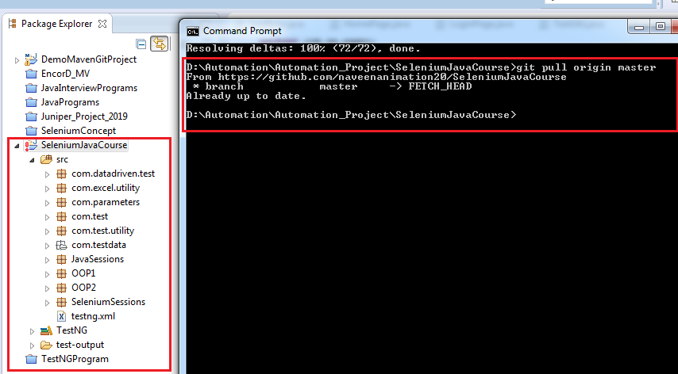

Git Push and Pull life cycle

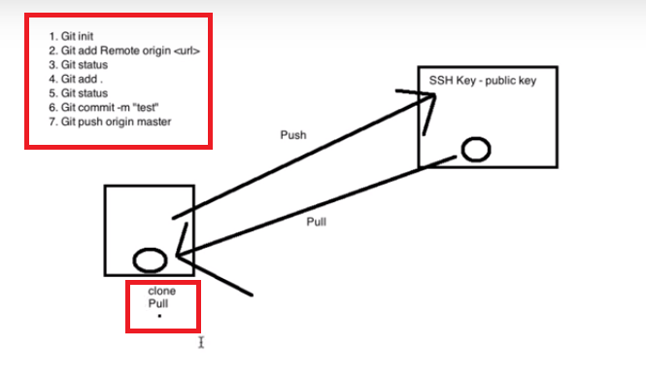

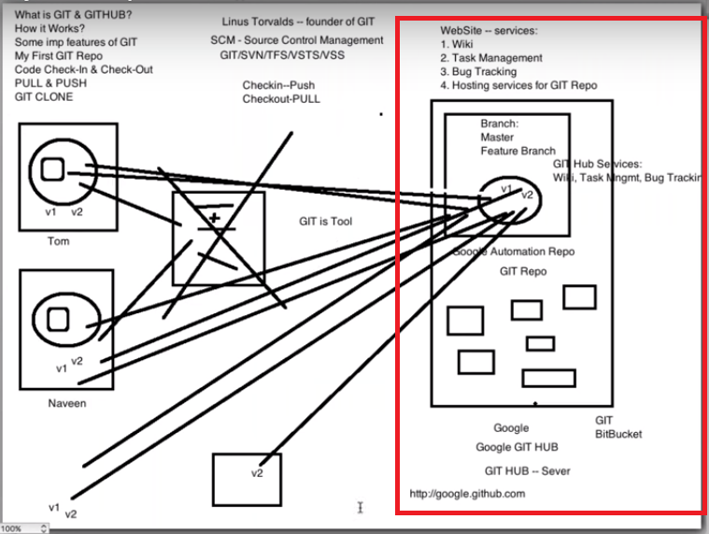

# Organization working on Git

In Organization we want to developer Project here is team Naveen, Sandesh, Babita and Prashant  
Naveen is create a Project structure in git and create master branch

Sandesh is working on Login page Babita is working on Reporting page and Prashant is working on Administration page now Sandesh has developed his code and create one branch in git Repository he will check in or push the code in that branch I.e **S.Branch** he rise one pull request to Naveen. Then Naveen will check his code and if he need to make some changes then he will inform Sandesh please correct these or add or update it again after Sandesh change he will rise pull request to Naveen once Naveen review code his will merge his code to Master branch   
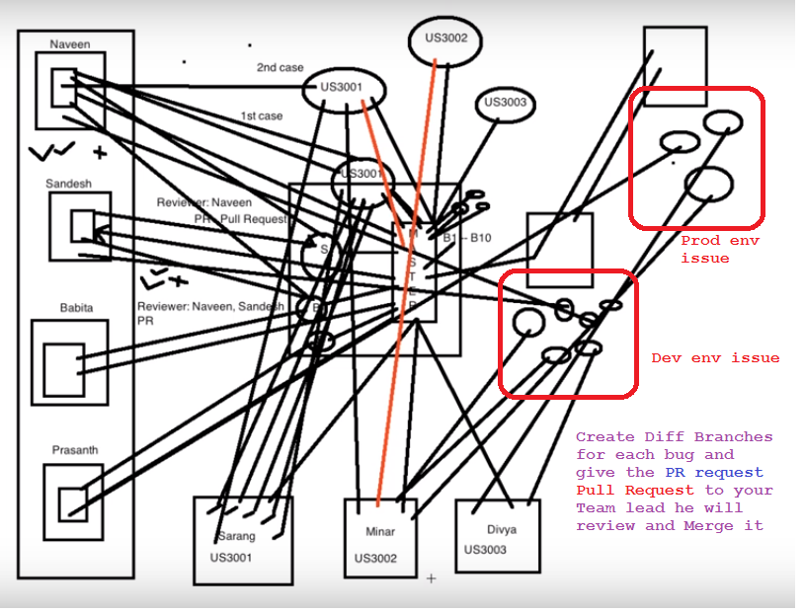

We some new member added in team Sarang,minar and Divya and they are working on agile Sarang will develpe his code every day and create a branch and will create a PR to Naveen to review so that each and every day Naveen will review code and merge into master branch.

Once all code development is done code given to QA team then they will test and move to Production if we have any issue on QA then they will create a bug say we have 5 bug then after assigned then to developer again they will create different branch and after fix they will generate pull request to Naveen after review done Naveen will merge into master same on prod site too.

Lets say in a project we have a branch and I have to pull the code code from that branch then

Got to project from cmd use command git branch it will return *master

* ***git pull origin nameofbrnach***
* ***git branch***
* ***git checkout nameofbrnach***
* ***git branch***

you will see from master to it will point  ***\*nameofbrnach***

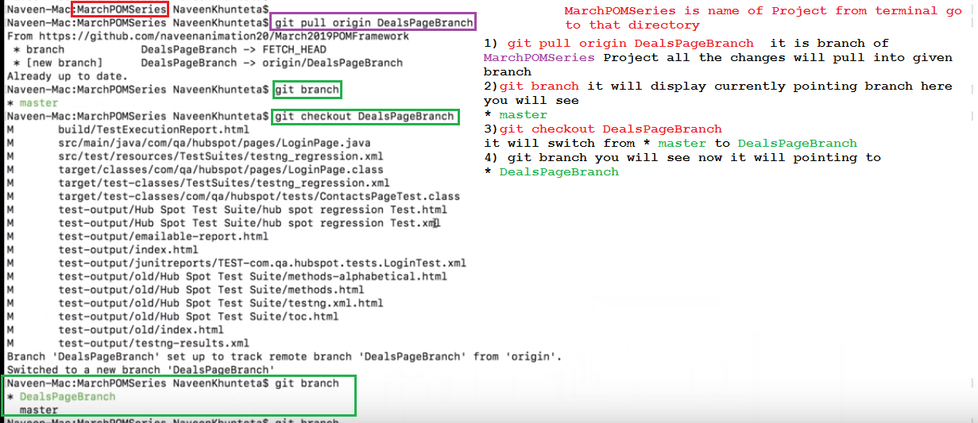

After that if you crate any new class or update any code in your current Project then following command or process we have to follow

* **git stauts** you will see one new file display in red color then add that file using
* **git add .**  it will update all files or
* **git add name_ of_ file** and enter again check status
* **git status** you will see that file will display in green it then it ready to commit then use
* **git commit –m** “new code has been added ” enter then
* **git push origin DealsPageBranch**

refresh your git repository you will see new code added now you have make PR Pull Request

I have added one my document in current Project

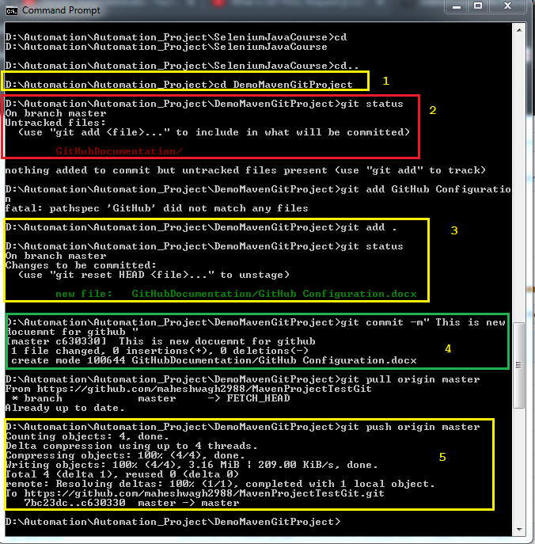

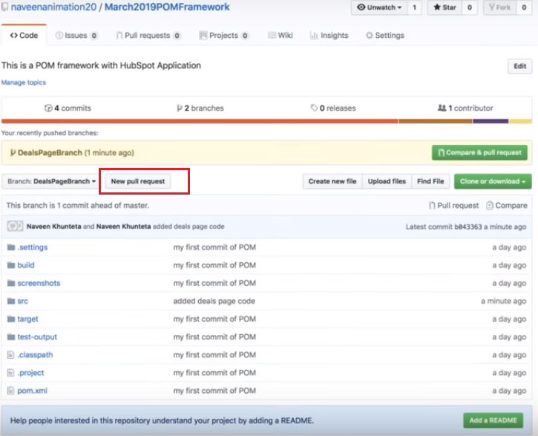

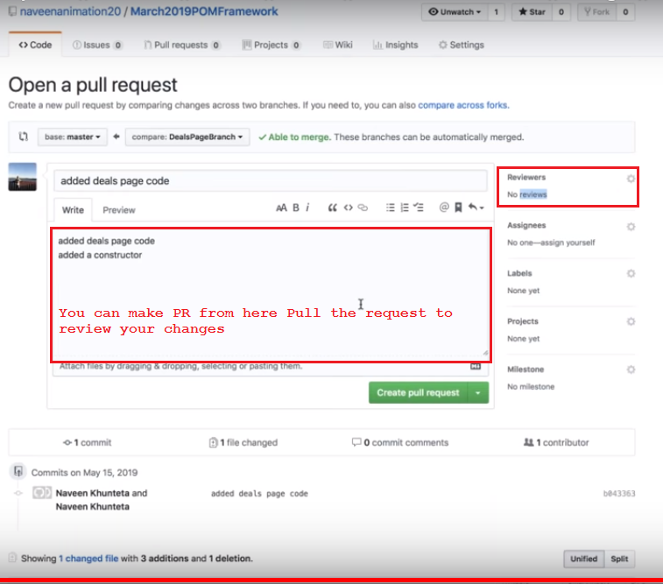

After code review by reviver he will comment on it yes it correct then you have to merge the code into master

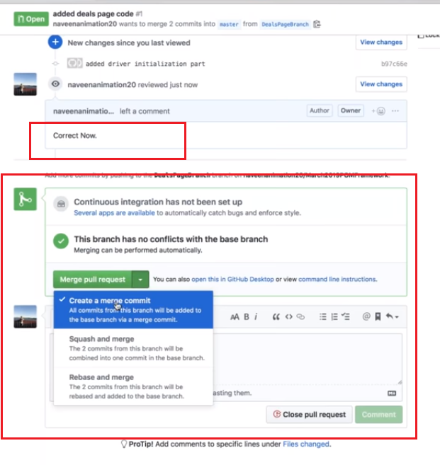

After merge if you refresh the page you will see new code added in your master too